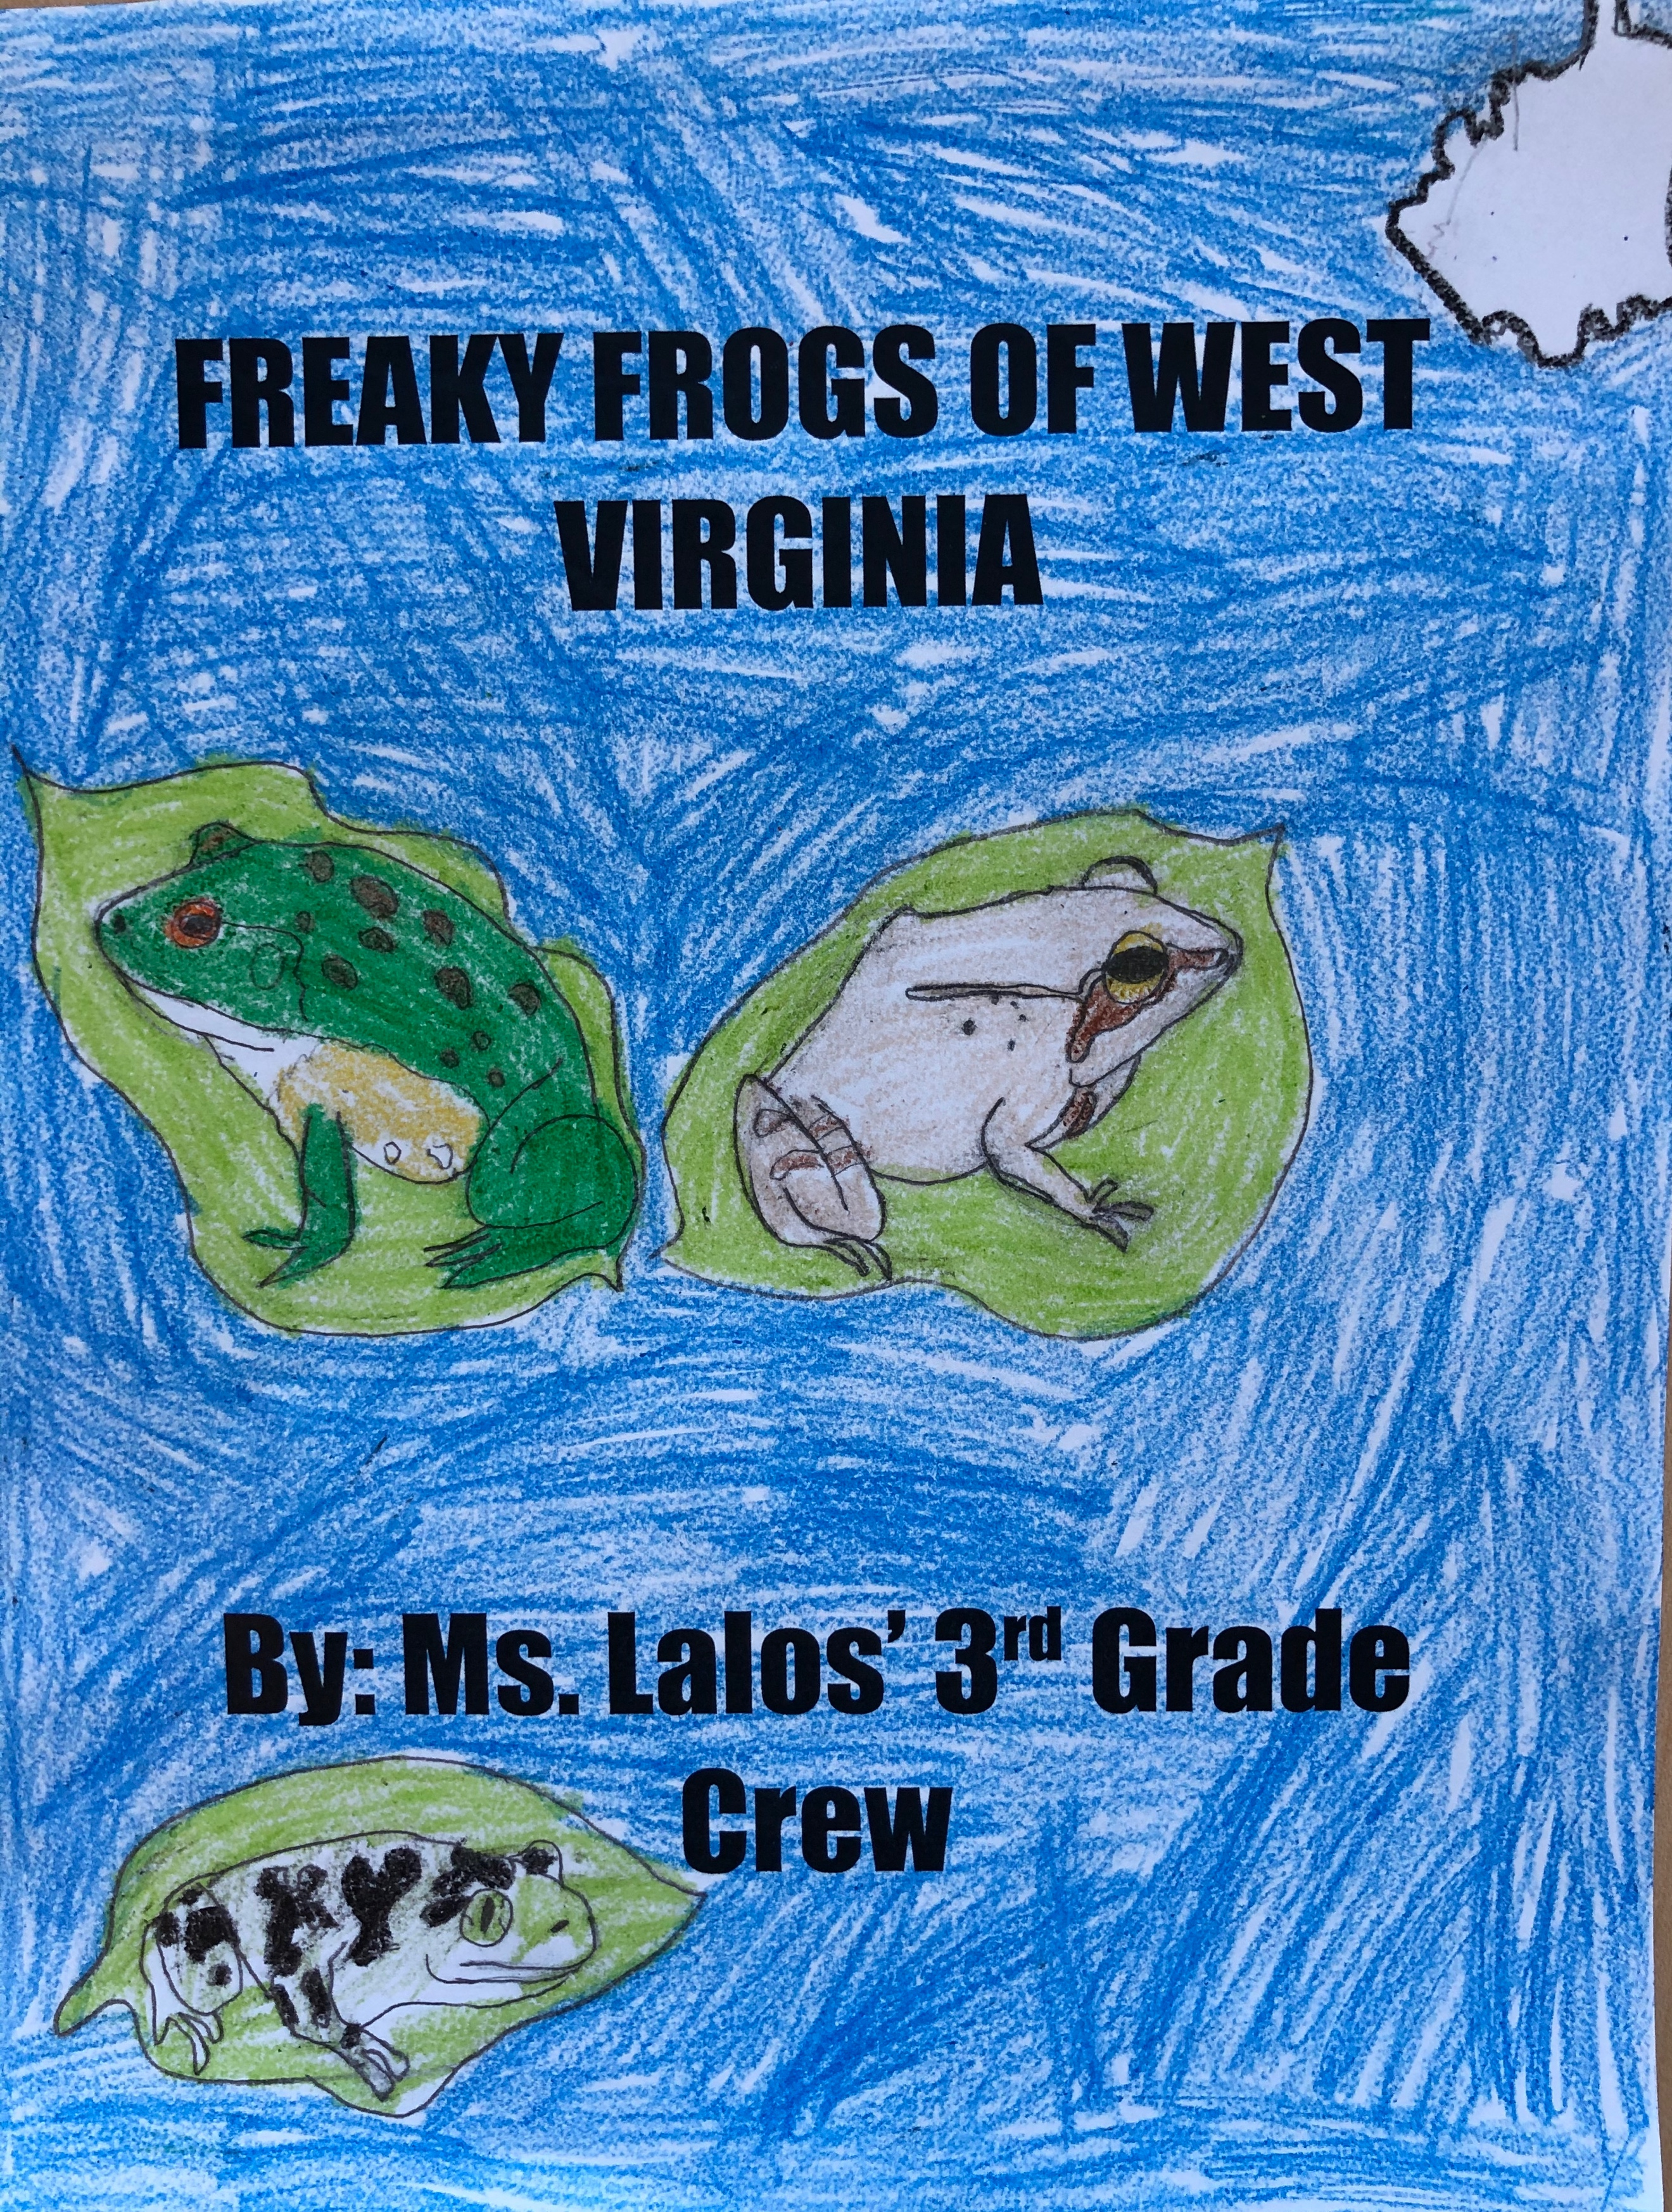



Cover illustrated by Samuel Bailey

© Explorer Academy, 2019-2020

ELA Module 2:
Adaptations of Frogs



I can write an informational paragraph about a West Virginia frog.
Eastern American Toad
By Samuel Bailey

The Eastern American Toad can be lots of colors. It can be red, brown or dark brown. The Eastern American Toad is about 2.0-3.5 inches long. Did you know that an Eastern American Toad has a dark body and somewhat flattened? Their eyes are small.

In addition to these physical adaptations the Eastern American Toad also has many behavioral adaptations. The Eastern American Toad is nocturnal but may also be active in the afternoon. During the daytime, they mostly rest under logs or stones or burrow in leaf litter. The Eastern American Toad eats bugs that fall from your porch lights.

The Eastern American Toad is about 2.0-3.5 inches long. The Eastern American Toad’s body is dark and somewhat flattened. The Eastern American Toad eats bugs that fall from your porch lights.

Gray Tree Frog
By Chloe Salisbury

The Gray Tree Frog is gray but it can look like a rock! The Gray Tree Frog has black smudges to make it look like a rock. The Gray Tree Frog is common in Minnesota and throughout the Eastern USA. It lives in the Great Swamp and the Ohio River. The Gray Tree Frog’s eggs hatch in less than a week and the tadpoles transform in about two months. Gray Tree Frogs have special physical and behavioral adaptations that help them to survive.

There are a couple of physical adaptations that keep the Gray Tree Frog safe. The Gray Tree Frog has short sticky fingers. Another freaky frog fact is it has black smudges on it. The Gray Tree Frog has black eyes it might be a little freaky but it is cute. Some frogs are different sizes. For an example, the Gray Tree Frog is between 1-1.8 inches long. The Gray Tree Frog is gray of course it is in its name and it is smooth.

In addition, these physical adaptations, the Gray Tree Frog also has many behavioral adaptations. In the winter, they hibernate under leaf litter, logs, and rocks. The Gray Tree Frog stays still and then eats the pray. The Gray Tree Frog lays its eggs hatch in less than a week. The Gray Tree Frog camouflage like a rock so the predators will not find it.

The Gray Tree Frogs black smudges help it camouflaged in nature. The Gray Tree Frog has short fingers to climb tree to be safe from birds, snakes and small mammals. In the winter, the Gray Tree Frog hibernates and gathers food like wax worms, dragonflies and other insects. The Gray Tree Frog’s tadpoles turn into a frog in about two months.

Fowlers Toad
By Keirnan Adkins-Coleman

So, let’s get started on the Fowler’s Toads. The Fowler’s Toads were named after naturalist Samuel Page Fowler. Their predators are birds and snakes. But it’s probably very hard to spot them. The Fowler’s Toad has special physical and behavioral adaptation that help them survive.

There are a couple of physical adaptation that keep the Fowler’s Toads safe. First, the Frogs mouth is so big it can eat things as big as it’s body. The Toad is really small while it’s a baby it’s really big while it’s an adult. It has a lot of warts. A Fowlers Toad’s skin is really bumpy.

In addition to all these physical adaptations, the Fowler’s Toad also has behavioral adaptations. The Fowler’s Toad has lots of camouflage. This camouflage usually only goes with leaves and or dirt. And it usually only blends in with red or brown leaves. They almost always camouflage in the dark.

After all this learning, you should know a lot about the Fowler’s Toad. But there’s still a lot more to know. Like the Fowler’s Toad is poisonous.

Eastern American Toad
By Niamah Dallas

I have become an expert on the Eastern American Toad. They have many interesting adaptations that help them survive. One adaptation is poison glands in their skin protect them from predators. Another adaptation is that their skin can change color to keep them warm or cool. Now, you know a lot about the Eastern American toad too.

Mountain Chorus Frog
By Khloe Hargis

Hi! I’m going to tell you about the Mountain Chorus Frog. They have tarnish brown skin and dark brown spots. They have texture like a rock. It helps them blend in. Mountain Chorus Frogs have special physical and behavioral adaptations that help them survive.

The Mountain Chorus Frog colors are tannish brown and it has dark brown spots. It also has a very dark line across its eye. I bet another frog is like this frog. Some Mountain Chorus Frogs don’t have spots. These frogs grow from 1.0 to 1.4 in long.

These frogs have physical and behavioral adaptations. They are all big and small. Mountain Chorus Frogs are relatively small frogs. An adult male total body length ranges from 26 to 30 mm. They are relatively solitary animals. They are only interacting with other members of the species. Males interacting the vernal ponds only mate in mating season.

These frogs are colorful and they look like a rock. Mountain Chorus Frogs the same predators as other frogs and prey. Their tannish brown skin helps them look like a rock their colors help them blend in super well!

Northern Green Frog
By Jude Nelson

Sometimes the Northern Green Frog isn’t always green. Sometimes it is blue or dark green. Another fact about the Northern Green Frog is that it’s back is very dark. It eats insects, smaller frogs, and sometimes bug larva. Northern Green Frogs have special physical and behavioral adaptations that help them survive.

There are many physical adaptations that keep the Northern Green Frog safe. Excellent hearing and vision really helps the Northern Green Frog. Their bulging eyes help them see their prey and predators from far distances. They also have sensitive ears for hearing their prey and predators. They have sensitive ears because their eardrums are on the outside of their bodies.

In addition to these physical adaptations, Northern Green Frogs also have behavioral adaptations. Males defend their territories with encounter calls, visual or body displays, chasing intruders, jump attacks, and wrestling. Smaller males without territories may exhibit similar behaviors. This species also admits a high stress call before leaping to safety after being disturbed. Northern Green Frogs have many ways to stay alive.

The Northern Green Frogs have the same predators and pray as other frogs, but it has special physical features and behaviors that help it survive. They have eardrums on the outsides of their head, and it’s bulging eyes help it see very good. The Northern Green Frog has a lot of adaptations that help it survive but I wonder why it is sometimes blue?

Eastern American Toad
By: Cartier Calvin

Hello, my fellow friends! We are going to learn about the Eastern America Toad. First, we are going to talk about Eastern America Toad’s size. It is 2 to 4 inches long. Next, its prey is spiders, worms and insects or slugs.
Some Eastern America Toads have some parts that are poison. The Eastern American Toad is usually brownish and yellow. I would tell someone my frog lives in the eastern United States and it does not hibernate. It has air inside it’s blood so it wo

American Bullfrog
By Aidyn Langdon

The American Bullfrog is the biggest frog because it reaches a body length of five inches. The color of the frog is green, brown and black. It lives in the Ohio River. The American Bullfrog has special physical and behavioral adaptations that help it survive.

First, there are a couple physical adaptations that keep the American Bullfrog safe. The American Bullfrog has rings beside its eyes. Next, the American Bullfrog uses long legs to jump far. It weighs 1.5 pounds. The American Bullfrog is brown and green.

In addition to these physical adaptations, the American Bullfrog also has behavioral adaptations.
The adaptations of the bullfrog have made it competitive. These frogs can run 5-8 inches in length. They can jump 7-10 inches. If any animal tries to eat the bullfrog, the poison could potentially kill that animal.

The American Bullfrog has the same predators and prey as other kinds of frogs but it has special physical features and behaviors that help it survive. If any animal eats it, the Bullfrog’s poison toxin
could kill that animal. It is brown and green. I like its colors it’s has rings it used camouflage.

Eastern American Toad
By Brook-lyn Johnson

The Eastern American Toad can be found in West Virginia. His skin is gold. His eyes are big. He has warts. He has reddish lines going down his back. His back legs are bigger.

Eastern Spadefoot
By Reagan Miller

The Eastern Spadefoot lives underground most of its life. Did you know Eastern Spadefoot is about two inches long? The Eastern Spadefoot breeds in pools filled with water. The Eastern Spadefoot is brownish with yellowish stripes. Eastern Spadefoots have special physical and behavioral adaptions
that help them to survive.

There are a couple of physical adaptations that keep the Eastern Spadefoot safe. Birds know that it is a toad by its bumpy skin, so it doesn’t get eaten. Eastern Spadefoot bumps are orange, and its length is 1.75-2.5 inches. Lastly, the Eastern Spadefoot can be distinguished from other toads because
of its eyes.

In addition to these physical adaptations, the Eastern Spadefoot also has a behavioral adaptation. Eastern Spadefoots hibernate underground. The Eastern Spadefoot species is found in sandy lowlands. The Eastern Spadefoot is a nice toad in the water and on land. When the Eastern Spadefoot camouflages, it looks like dirt and grass.

The Eastern Spadefoot has the same predators and prey as other kinds of frogs. But it has special features and behaviors that help it survive. Eastern Spadefoots length can be up to 1.75 of 2.5inches. The Eastern Spadefoot lives underground most of its life.

Spring Peeper
By Savannah Wick

Today, we are going to be learning about the Spring Peeper. You may be asking what does the Spring Peeper look like? It is the color gray. Also, did you know that Spring Peepers are the most common frog in West Virginia? The call of a of a Spring Peeper is one of the earliest signs of spring coming. Spring Peepers have special physical and behavioral adaptations that help them to survive.

First, of all the Spring Peeper is small and hard to see. They only reach about one and a half inches long. The Spring Peeper has a dark ‘X’ on its back. They also have toe pads for climbing and grabbing on plants. The Spring Peeper has gray and brown skin which camouflages it from predators.

In addition to these physical adaptations, the Spring Peeper also has a behavioral adaptation. The Spring Peeper is nocturnal and is up only at night. The Spring Peeper hibernates under leaf piles. The females only lay eggs around aquatic plants in the shallow pools.

The Spring Peeper is most common in West Virginia. The Spring Peeper only gets about one inch long. Their predators are diving beetles and giant water bugs. It eats things like small insects and flies.
Northern Leopard Frog
By Kayleigh Small

Hello readers! Today you will be reading about the Northern Leopard Frog. Let’s talk about what they look like. They have black and brown spots. They are green and brown. They can also be black. They are 3 to 5 inches long.
Let’s talk about the frog’s adaptations. They have spots to trick its predators. It’s a poison frog. They have different colors that blend in with the wild. They look alike with different frogs. They have legs that can change to make it a better at swimming.
In addition to the physical adaptations, the Northern Leopard Frog also has a behavioral adaptation. They are not dangerous to humans but if they feel threatened, they have some toxins. Sometimes they may be jumping in zig-zag patterns. During the winter, they go and hibernate. When they are scared they find a place that looks like it.
The Northern Leopard Frogs are green and brown but sometimes they look different. My frog gets scared easy, so when it feels threatened, it finds a place that looks like it. My frog can get up to three to five inches long.

Eastern Cricket Frog
By: Jamelle Montgomery

My frog is the smallest frog in West Virginia. My frog has a rare mask and lives in shallow bodies of water. They are not good climbers. They do not go high in trees. It eats insects and crickets. It sounds like clicker marbles when it calls.
My frog has dirty skin and has bumps on its back. When my frog sits on a dirty surface, it looks like a rock. My frog is rare and can be many different colors.
The Eastern Cricket Frog has special physical and behavioral adaptations that help them to survive. They are preyed upon by hundreds of species including birds, fish and others. In efforts to escape predators, they are capable singing, jumping and are excellent swimmers.
Finally, The Eastern Cricket Frogs are restricted to the western part of Ohio, where they inhabit the shores of ponds and streams. The size and a color of a Cricket frog is small and brown. They are excellent swimmers.

Eastern Spadefoot
By Miley McCormick

Did you know the Eastern Spadefoot lives underground? It has two yellow lines on its back. It’s very rare in Ohio. A snake can eat them. Their prey is flies and earthworms. Eastern Spadefoots have special physical and behavioral adaptations that help them to survive.

It has two yellow lines on its back. It has brown around its eyes. They are green. They have orange spots on their sides and some have black stripes on their legs.

The Eastern Spadefoot is a nocturnal species who like to burrow into sandy or loose soil. They can survive in lots of waters and their diet is mainly insects and earthworms. They have a spade like projections on the inside of their feet that are used for digging. They produce a musty/peppery secretion that some people can have an allergic reaction to. They have a lifespan of 12 years.

Eastern Spadefoot has the same predators and prey as other kinds of frog but it has special physical features and behaviors that helps it survive. They live in Ohio and they have to two yellow lines on their back. Their prey is flies and earthworms.

Upland Chorus Frog
By Caiden Davis

Today, we’re going to be studying the Upland Chorus Frog. The Upland Chorus Frog looks similar to a Mountain Chorus Frog but if you look close, you will see that it’s an Upland Chorus Frog! The Upland Chorus frog has many dots on it. The Upland Chorus frog is one of the smallest frog ever. The Upland Chorus frog has special physical and behavioral adaptation that help them survive.
The Upland Chorus frog has lines down its body. The Upland Chorus frog is 1.5 inches long and it lives in swampy areas like moist woodlands. The Upland Chorus frog lives in West Virginia.
In addition to these physical adaptations, the Upland Chorus frogs also have a behavior adaptation. The Upland Chorus frog is secretly nocturnal, that means they go to sleep at day and they stay up at night. The Upland Chorus frog rarely encounter non-breeding frogs however non-breeding individuals are occasionally seen in woodlands. Like most frogs, they eat insects.
The Upland Chorus frog has the same predators and prey as other kinds of frogs but it has special physical features and behaviors that help it survive. The Upland Chorus frog is secretly nocturnal, that means they’re awake at night and they’re sleep during the day. The Upland Chorus frog is 1.5 inches long.

Wood Frog
By Arion Barret

Hello fellow people! Today were learning about the Wood Frog. Wood Frogs eat insects and bugs. Wood Frog predators are gators, snakes, ribbon, water snakes, and herons. Wood Frogs live in trees because predators can’t reach it. Wood frogs can hibernate. One of the Wood Frog adaptations is it lives high in trees so the predators can’t eat it. Wood Frogs have special physical and behavior adaptations that help them survive.
There are a lot of physical adaptations that keeps the Wood Frog safe. First, it is tarnish and brownish colors. Another thing about the Wood Frog is that it is 1.5 to 3.25 inches long. The Wood Frog eats insects and bugs and worms, slugs, and snails. The Wood Frog is as big as 0.25 oz.
In addition to these physical adaptations, the Wood Frog also has a behavior adaptation. The Wood Frog buries itself and goes into a deep hibernation. The Wood Frog lays its eggs on an egg mat. The Wood Frog lay their eggs in vernal pools. The Wood Frog lives for three years.
The Wood Frog camouflages well. One of the Wood Frog behavior adaptations is the Wood Frog buries itself and goes into a deep hibernation. Another of the physical adaptations is the Wood Frog is 1.5 to 3.25 inches long. The Wood Frog lays its eggs in a vernal pool. Finally, the Wood Frog eats insects, bugs, worms, slugs, and snails.

Fowlers Toad
By Liam Fike

Hi, did you know that the Fowlers Toad resembles an Eastern American Toad? The Fowlers toad has physical adaptations that help it survive.
The Fowlers Toad has warty skin. The Fowlers Toad tadpoles can develop in a drying vernal pool. They are brown. They are pretty small. They can be tan.
In addition, the Fowlers Toad is really cool! They reach breeding age when they are two years old. They lay 20,000 eggs! They can live for five years. They burrow underground to stay away from predators.
The Fowlers Toad has all kinds of predators and prey. Its predators are cranes and some bigger spiders. They ambush their prey by hiding in the grass. They will eat smaller frogs and crickets. They have a little bit of venom. It has a chemical that makes it taste bad to predators. It also blends in with its environment.

Eastern American Toad
By Elizabeth Triplett

I am going to tell you a little about the Eastern American Toad. Its habitat is the northeastern U.S. and the Midwest states. It eats grubs and worms among other things. The Eastern American Toad has special physical and behavioral adaptations that help them survive.

Upland Chorus Frog
By Parker Rose

Do you think the Mountain Chorus Frogs are the same as Upland Chorus Frogs? Wrong! Upland Chorus Frogs have a line count from its eye to its back and spots it’s legs. It’s related to Tree Frogs. It has sticky toepads on its fingers. Upland Chorus Frogs have special physical and behavioral adaptations that help them to survive.
They are 0.75 – 1.4 inches long. It has grey or tan skin with dark dorsal strips that are narrow or broken into a series of dashes or spots they have a light line along the upper lip and 2 dark triangles are often present between the eyes. Fun fact, Upland Chorus Frogs are Tree Frogs. Tree Frogs have sticky toepads that help them climb.
The Upland Chorus Frog breeds between February and May. It’s mating call sounds like creek or “preep”. Eggs are laid in clumps of approximately 1000 eggs. These clumps are attached to vegetation. Upland Chorus Frog are secretive, nocturnal frogs. They are rarely seen except immediately after it rains.
The Upland Chorus Frog is a Chorus Frog, but Chorus Frogs are Tree Frogs. So, Upland Chorus Frogs
have the same predators as other Chorus Frogs but it stays
hidden by calling after rain fall because predators are not
active at rain fall. Upland Chorus Frogs have a
dorsal line from its snout to its back. These features
help it survive and make it different from other frogs.

Spring Peeper
By Eidolon Spurlock

The Spring Peeper got its name because its chirping call marks the beginning of spring. Spring Peepers are very small. They only grow one to one and a half inches long. They live in Canada and the Eastern US. They eat flies, beetles and small spiders. Spring Peepers have adaptations that help them survive.
The Spring Peeper frog is tarnish brown color. It is a small frog and it has spots. Their eyes are a sideways oval shape. A Spring Peeper can grow one to one and a half inches. They eat beetles, ants, flies and small spiders.
The Spring Peeper frog has many different behaviors. Spring Peeper frogs usually are most active at night. They travel an average of 6.1 to 39.6 meters a day. Male northern Spring Peepers spend the winter burrowed into soil or under logs and leaves.
The Spring Peeper is like other frogs but it has its differences too. My favorite behavior of the Spring Peeper is its chirping that marks the beginning of spring. Who knew something so small could be so cool!

GALLERY
I can draw a scientific drawing of a West Virginia frog.

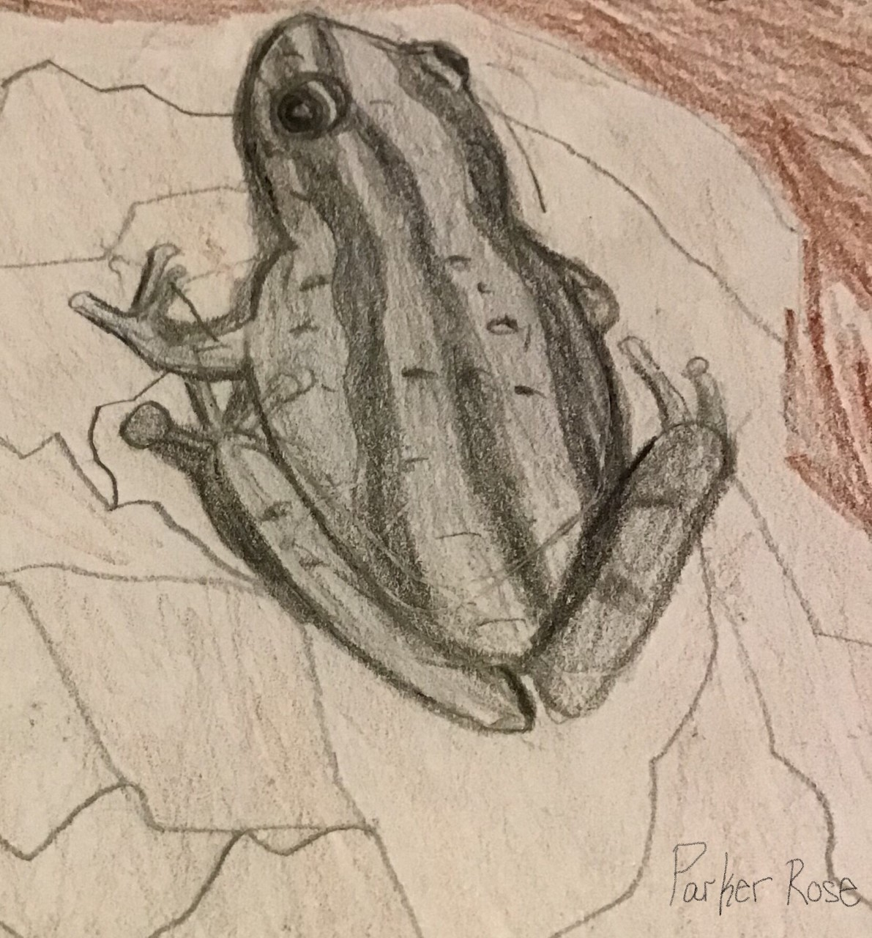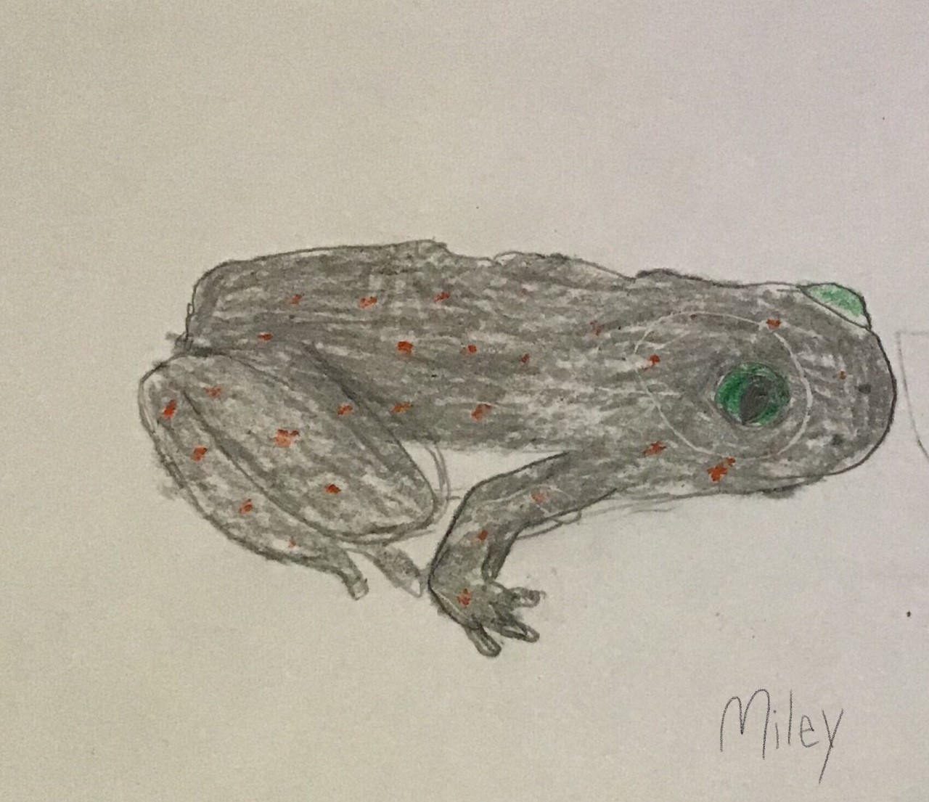
Upland Chorus Frog Eastern American Toad
By Parker Rose By Miley McCormick

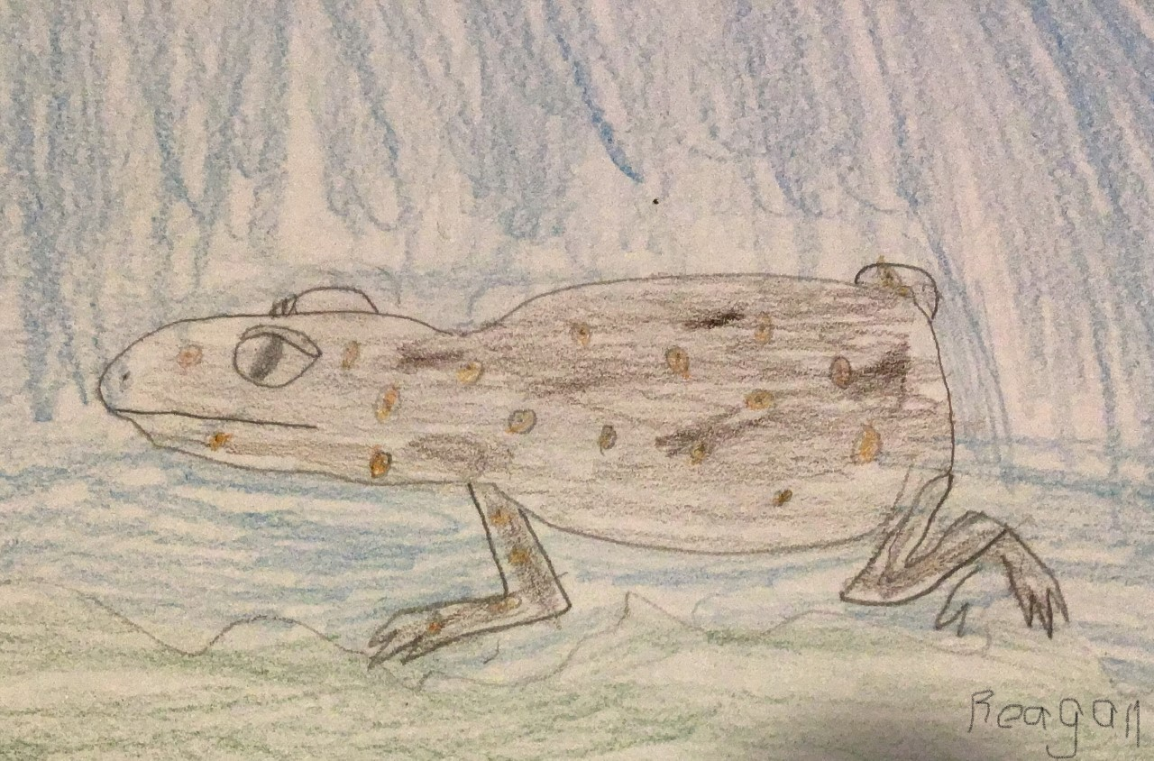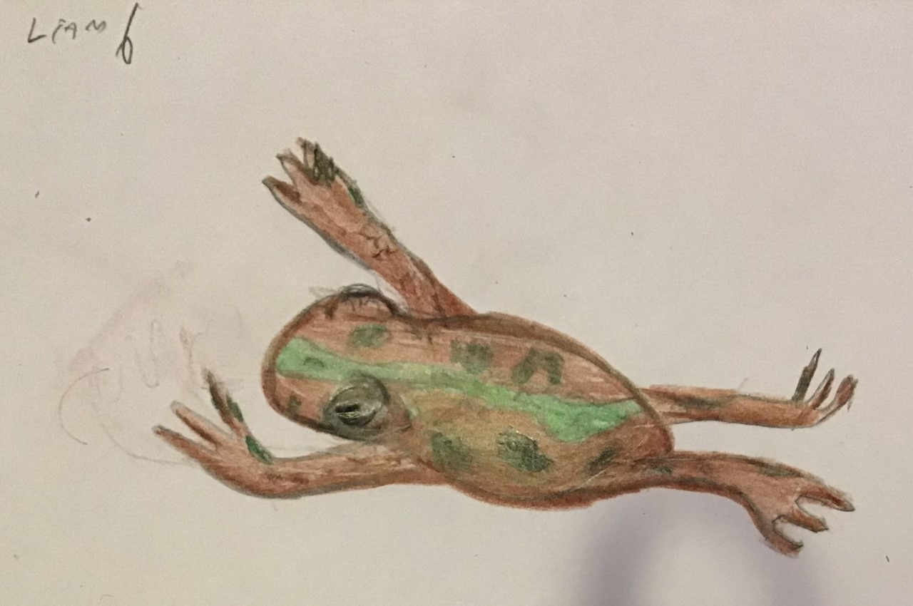
Eastern Spadefoot Fowler’s Toad
By Reagan Miller By Liam Fike

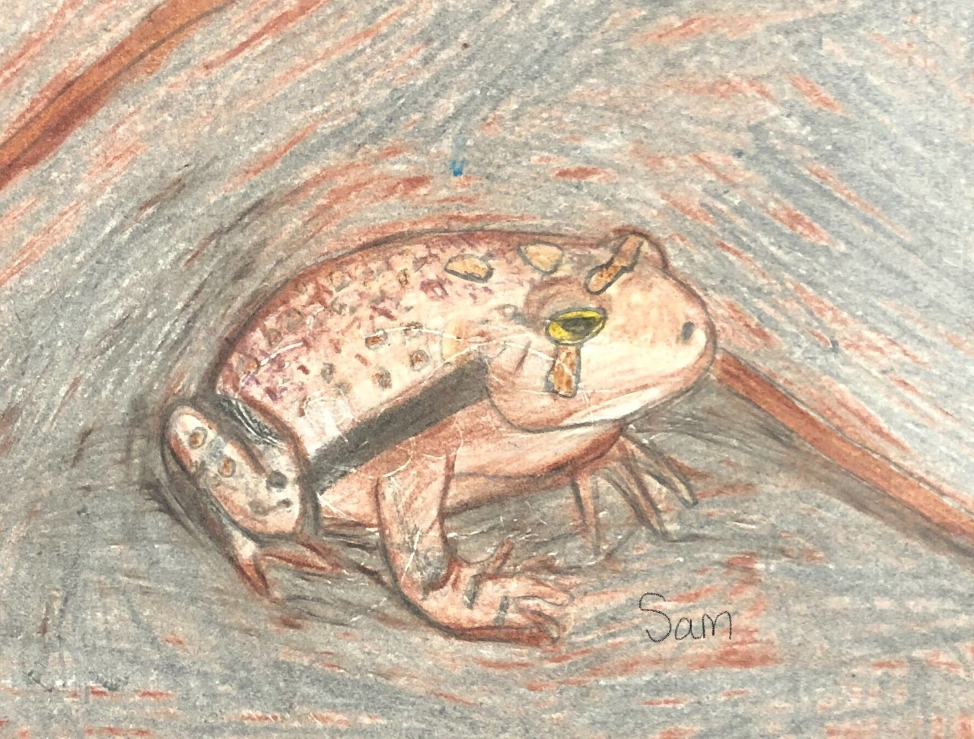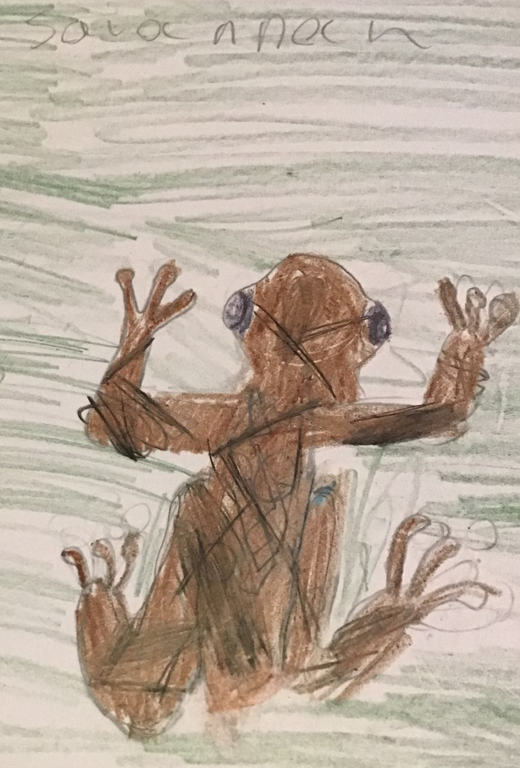
Eastern American Toad Spring Peeper
By Samuel Bailey By Savannah Wick

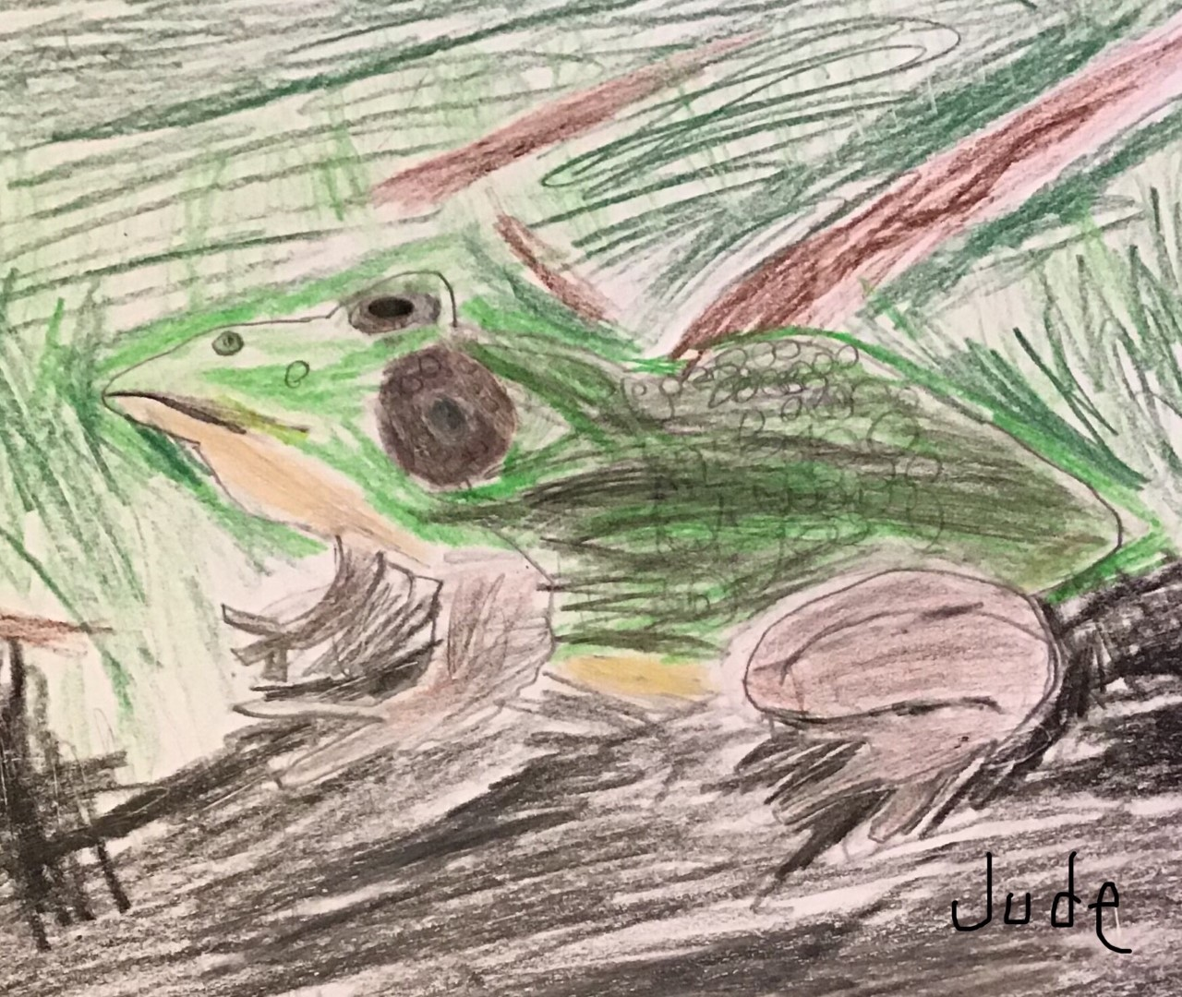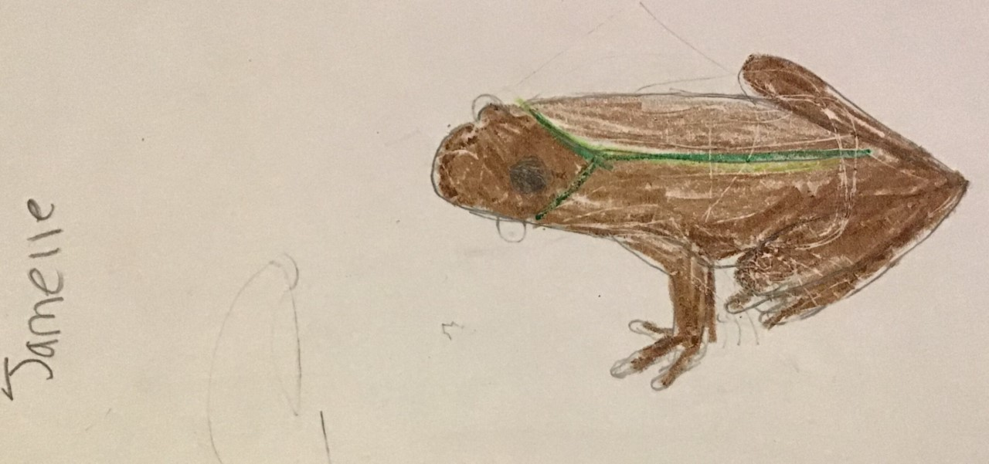
Northern Green Frog Eastern Cricket Frog
By Jude Nelson By Jamelle Montgomery

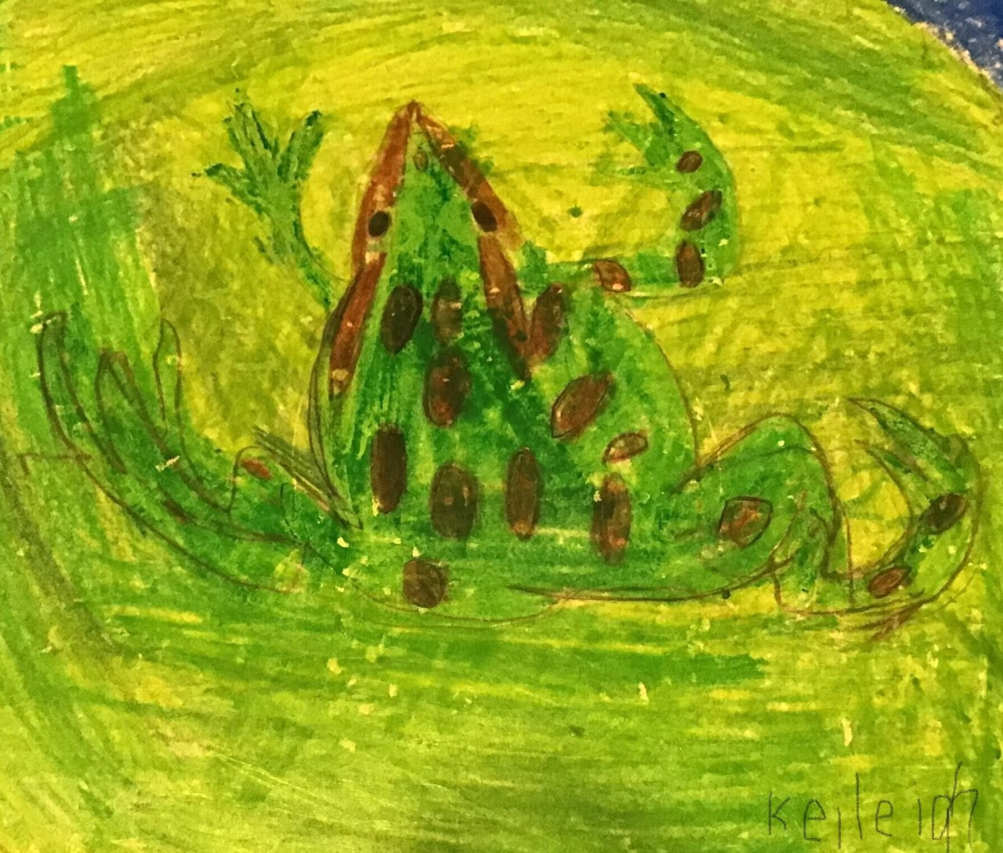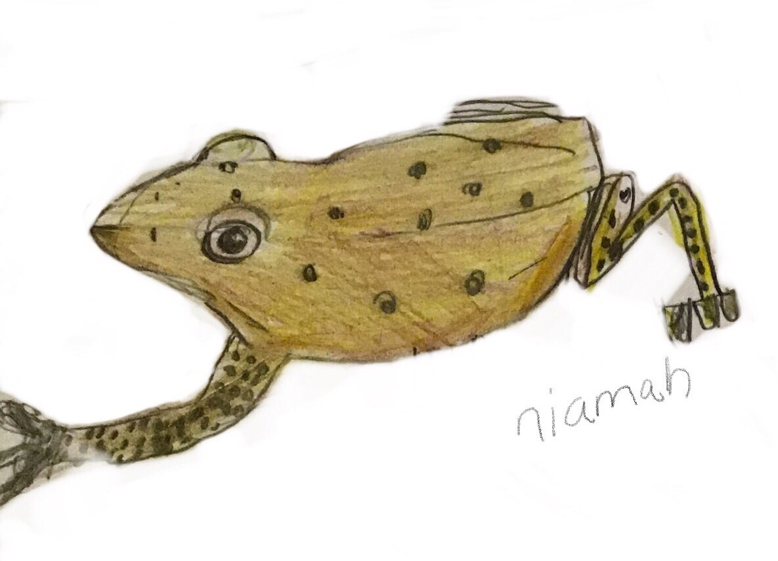
Northern Leopard Frog Eastern American Toad
By Keileigh Small By Niamah Dallas

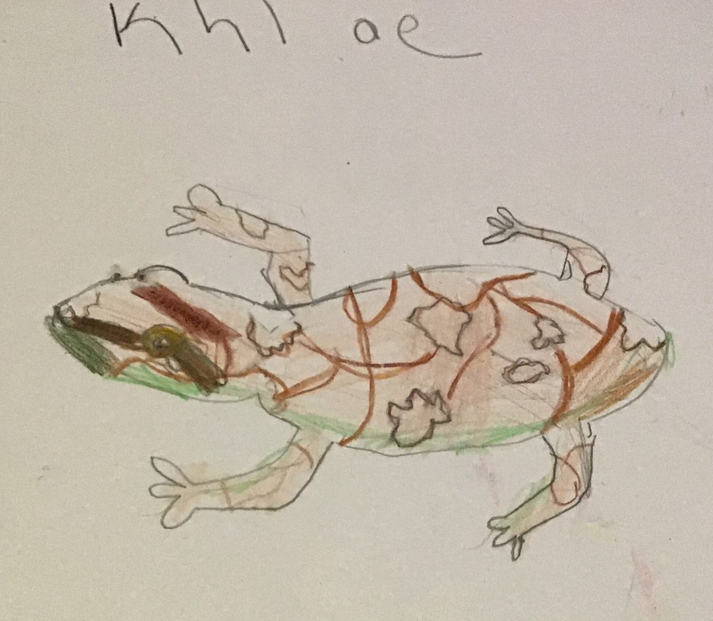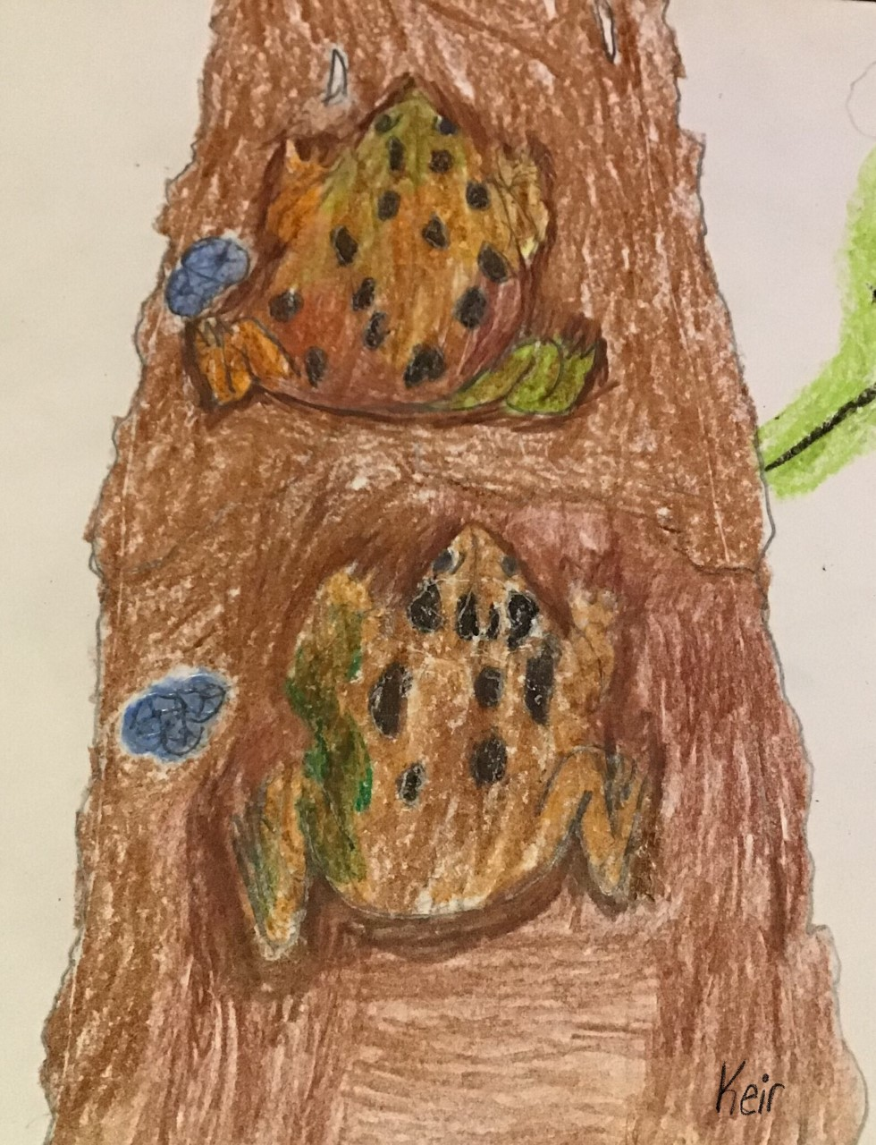
Mountain Chorus Frog Fowlers Toad
By Khloe Hargis By Keirnan Adkins-Coleman

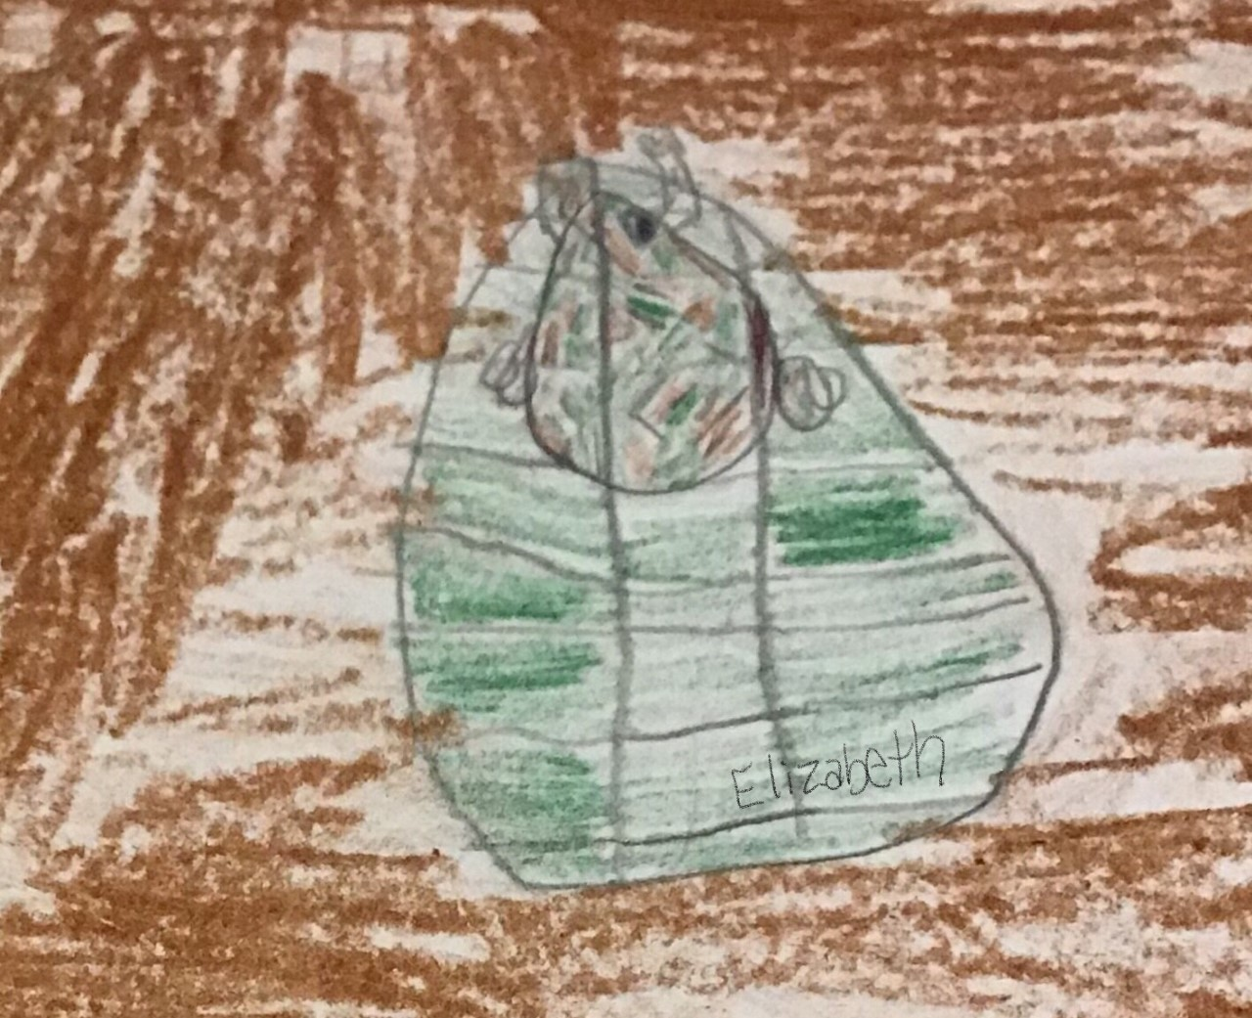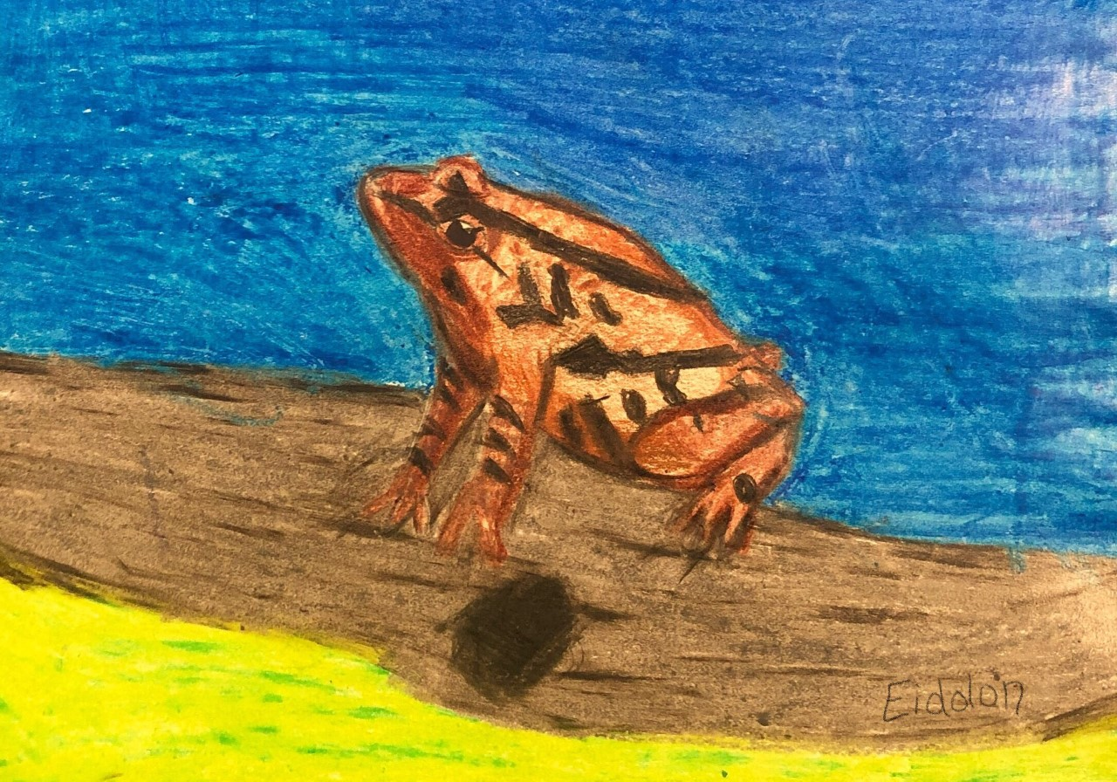
Eastern American Toad Spring Peeper
By Elizabeth Triplett By Eidolon Spurlock

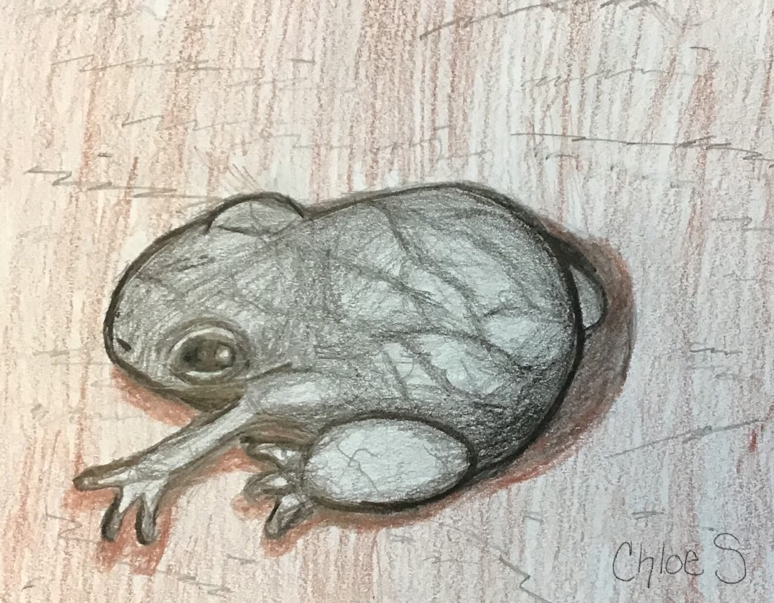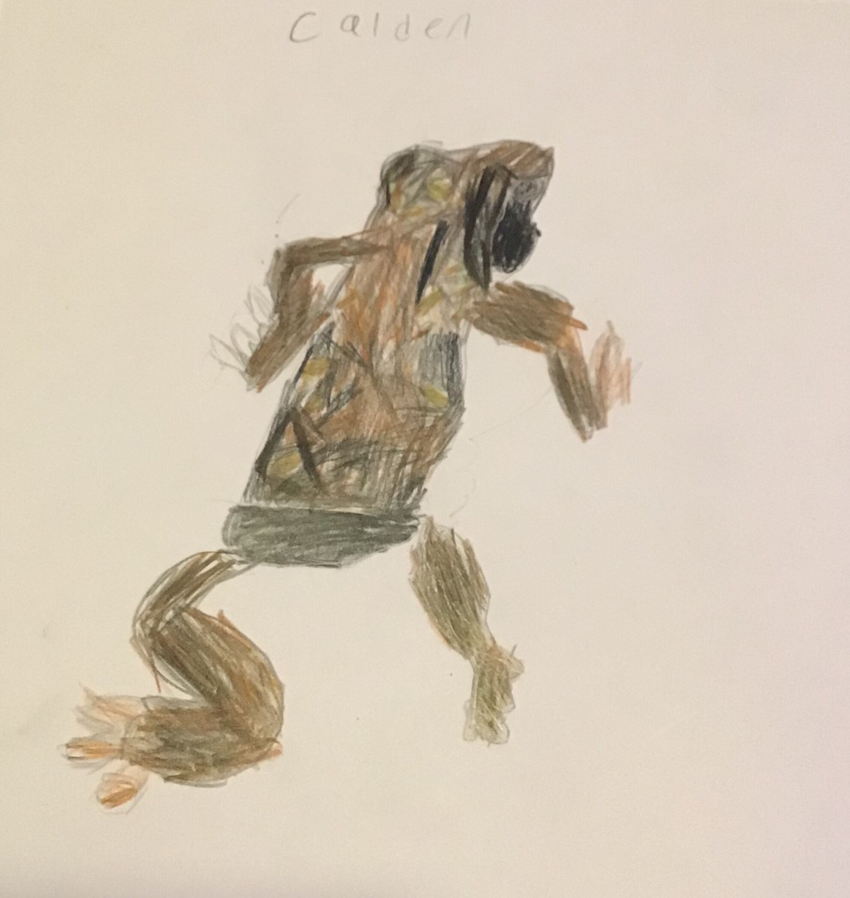
Gray Tree Frog Upland Chorus Frog
By Chloe Salisbury By Caiden Davis

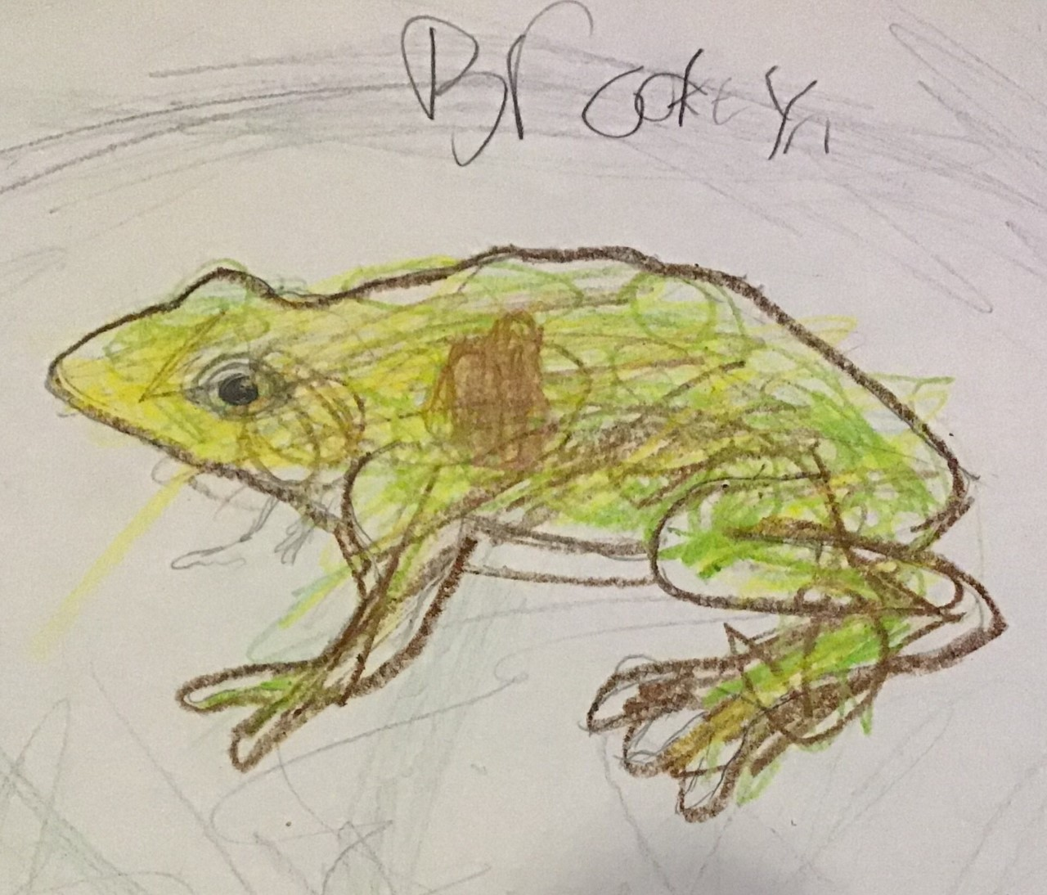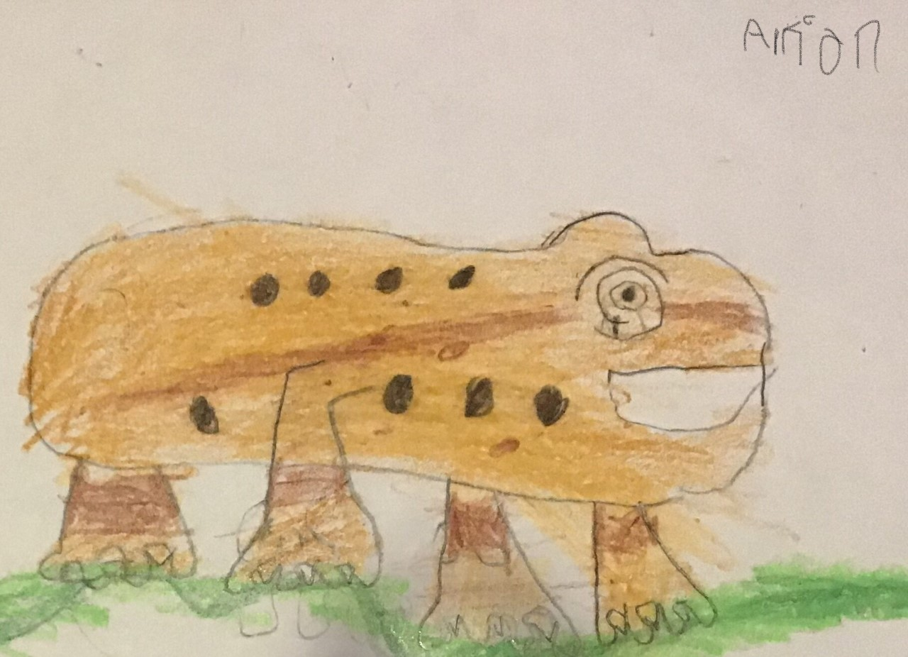
Eastern American Toad Wood Frog
By Brook-lyn Johnson By Arion Barretto

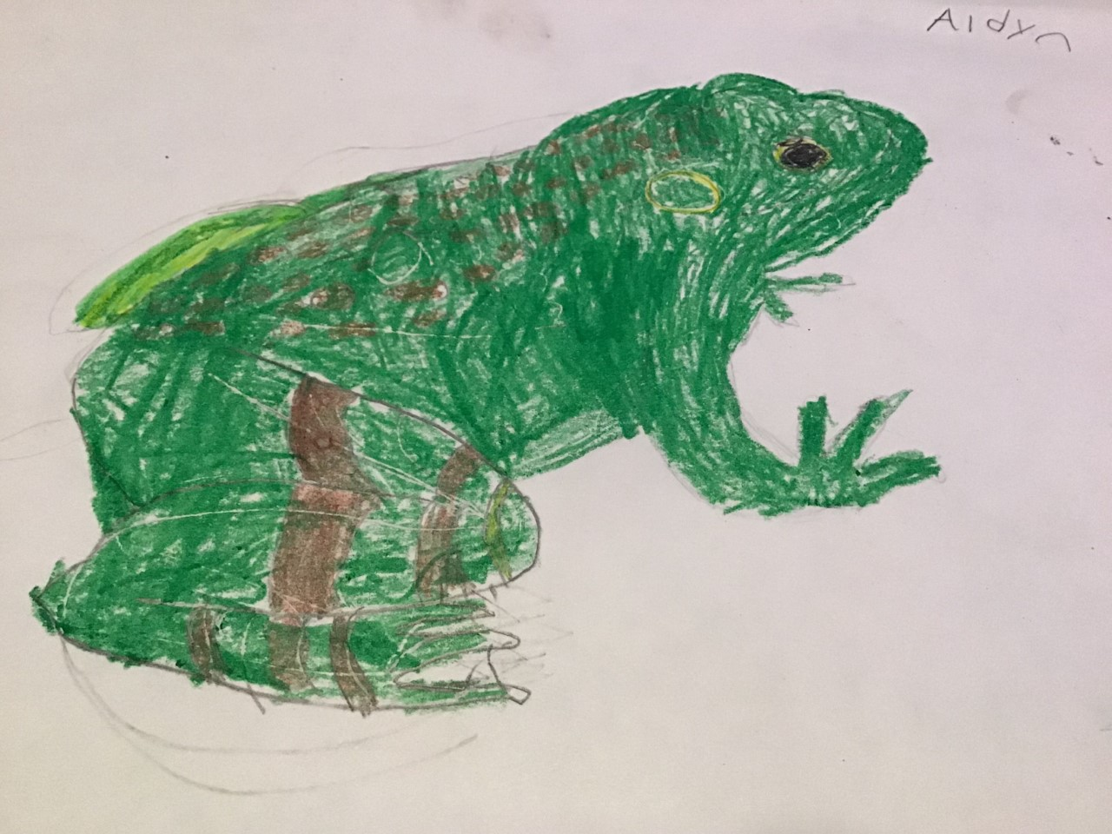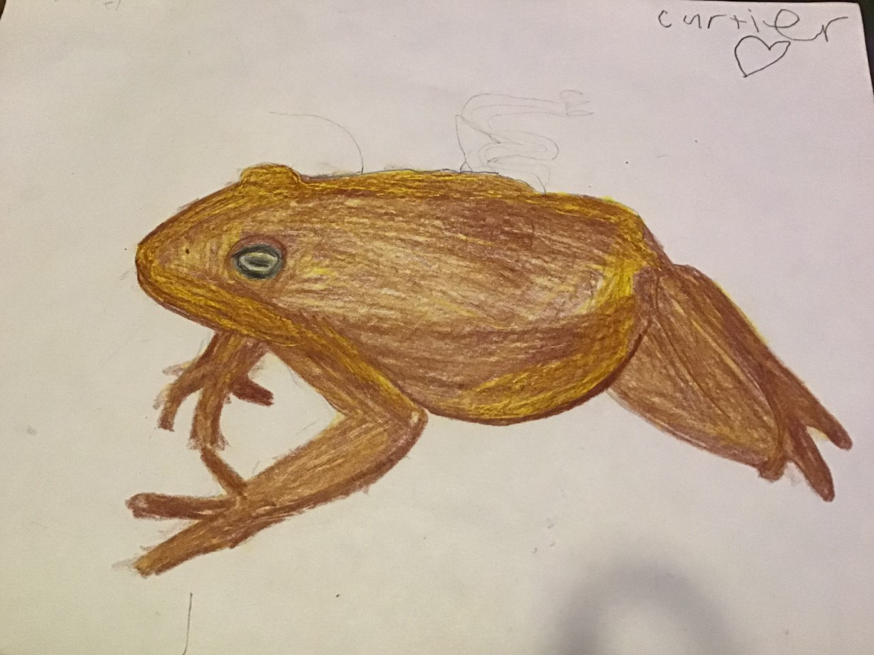
American Bullfrog Eastern American Toad
By Aidyn Langdon By Cartier Calvin

